LABORATORY CHAPTER №5

TOPIC. DATABASE SYSTEMS

Database - collection of data and the relationships between them. As an example, an example of an organizational structure, containing offices, departments, employees, their work plan.
Microsoft Access - is a flexible program that allows you to work with both simple and complex databases. It should be mentioned that this is a relational database that is a database that allows you to define the relationship between the various categories of information (such as, for example, between the departments and data about their employees).
Components. Any database basis are composed on data stored in it. However, in an Access database, there are other important components, which are called objects:

Table is an object that is used to define and store data. All information are stored in a tables, in which columns are parameter of some objects and all rows (records) represents information about one single object. When you create a new table, Access asks you to define fields which is also known as column headings
- Each field must have a unique name, and data type.
- Tables contain fields or columns that store different kinds of data, such as a name or an address, and records or rows that collect all the information about a particular instance of the subject, such as all the information about a customer or employee etc.
- You can define a primary key. A primary key is a field or set of fields with values that are unique throughout a table. Values of the key can be used to refer to entire records, because each record has a different value for the key. Each table can only have one primary key. Access can automatically create a primary key field for you when you create a table, or you can specify the fields that you want to use as the primary key. This article explains how and why to use primary keys.

Type of table fields. Next step after drawing up the fields for the table plan - is the choice of the type of fields. Type field identifies the data that can be entered into this field, the format that can have the value of this field and the operations that can be performed with the data of this field. In Microsoft Access, there are many types of fields. They are listed below:
- Counter. In this field, Access automatically enters a number with the addition of each new entry in the table. This field automatically sets the sequence numbers for each record, in ascending order.
- Currency. This type of field is used for entering monetary values.
- Date / Time. In this field you enter the date or time, or a combination thereof.
- Hyperlink. This field contains the hyperlinks addresses used to access the Web-pages, objects or other database files.
- Lookup Wizard. In the field of this type is triggered Lookup Wizard, which imposes restrictions on the values in the field. Values / search results can come from the input list, you, table or query.
- Memo. The field of this type may include text unlimited length.
- Numeric. In the field of this type may be entered in any format numeric data.
- Field object OLE. Contains objects such as images and Word documents.
- Text. The field of this type contains the text: letters, numbers and other characters.
- Boolean (Yes / No). In the field of this type is stored one of two possible values: "true" or "false". These values can be "yes / no", "true / false", "man / woman" and so on.

Query- An object that provides a custom view of data from one or more tables. Queries are a way of searching for and compiling data from one or more tables.
- Running a query is like asking a detailed question of your database.
- When you build a query in Access, you are defining specific search conditions to find exactly the data you want.
- In Access, you can use the graphical query by example facility or you can write Structured Query Language (SQL) statements to create your queries.
- You can define queries to Select, Update, Insert, or Delete data.
- You can also define queries that create new tables from data in one or more existing tables.

Form is an object in a desktop database designed primarily for data input or display or for control of application execution. You use forms to customize the presentation of data that your application extracts from queries or tables.
- Forms are used for entering, modifying, and viewing records.
- The reason forms are used so often is that they are an easy way to guide people toward entering data correctly.
- When you enter information into a form in Access, the data goes exactly where the
- database designer wants it to
- go in one or more related tables

Linking multiple tables into a single structure
Creating links between tables is the final stage of designing a table system. At this stage, the relations between the primary keys and secondary fields that are planned during the construction of the tables are actually recorded. After that, you can start developing the interface of the future application (creating queries, forms, reports, etc.).
There are two main reasons for creating relationships (links) between tables: maintaining referential integrity and specifying how to select data from multiple tables. Lnks defines the relationship between the fields of tables that have the same meaning, for example, between the primary key of one table and the another key in different table. Relationships can be set at the database level (in this case, supporting referential integrity of the data is possible) and at the query level.
Links at the database level are permanent links and are relevant to any actions performed on the tables (for example, update or delete requests, macros or Visual Basic programs that modify the data of related tables, etc.). Relationships at the query level are temporary and relevant only at the time of the query in which they are specified.
There are several types of relationships between tables:
- One-to-many. It is the most commonly used form of relationships. In this case, each record in table A may correspond to many (or none of them in some cases) records in table B. In turn, each entry in table B corresponds exactly to one entry in table A. Table A in such a relationship is called the main table, and table B is related or subordinate.
- Many-to-many. Many records from table A can correspond to many records from table B (and vice versa). Such a connection in Microsoft Access can be organized using the third auxiliary table, in which each primary key from table A is associated with a primary key from table B. In fact, a many-to-many relationship is several one-to-many relationships. In this case, tables A and B are main tables, and the auxiliary table is related to them. This type of communication is used less frequently.
- One-to-one. One record of table A corresponds exactly to one record of table B and vice versa. This type of communication is almost never used. The only case where the use of this type of connection is justified - a breakdown of a table containing a very large number of fields into several parts.

ADDITIONAL TASK FOR MASTERING SKILLS

Creating a Database
1. Start Microsoft Access 2007 (2013).
2. Press the button New database (Empty database).
3. Set the name of the new database - "Notebook ".
4. On the menu tab Home (Главная) in the Tables toolbar, click the Mode button (Режим) and
choose Design mode (Режим конструктора). Give the name “Friends” to the table.
5. Enter the field names and specify the types of data to which they relate:

Field name  (Имя поля) | Data type  (Тип данных)
№ | Counter (Счетчик)
Last name | Short text (Текстовый)
First name | Short text (Текстовый)
Address | Short text (Текстовый)
Post index | Numeric (Числовой)
Phone | Short text (Текстовый)
Hobby | Short text (Текстовый)
Email | Link (Гиперссылка)

6. Exit the Design mode Mode button → Table mode (Режим таблицы), save changes.
7. Open the "Friends" table by double-clicking it in the navigation panel and fill it with 10 lines.
8. Add the "Middle name" and "Date of birth" fields, for this:
1) position the cursor on the field before which you want to insert a new column; (click
the left mouse button on the column)
2) at ribbon in Table mode → toolbar “Fields and columns” → Insert (For Access 2013
“Work with tables” → Fields → in the “Add / Remove panel”, specify the type of field to add); (ленты Режим таблицы → панель инструментов Поля и столбцы → Вставить (Для Access 2013 Работа с таблицами→Поля→на панели «Добавление и удаление» укажите необходимый тип поля для добавления));
3) by double-clicking on Field1, rename it to "Middle name" and Field2 to "Date of
Birth".
9. Switch to Design mode. 10. For the "Date of birth" field, set the “date / time” data type; and at
“Field properties” panel (Field format), select the Short date format (в свойствах поля
(Формат поля) выберите Краткий формат даты).
10. Format the table as follows (Main menu bar → Text Formatting panel) → Advanced settings
(symbol): Главная→ панель «Форматирование текста) → Расширенные
настройки (символ )):
1) color of the grid is dark red;
2) background color - blue;
3) text color is dark red, the size is 12 pt, the outline is italic.
11. Rename the "Hobby" field to "Hobbies".
12. Delete the record at number 8. (right click on the left of the table line and select – Delete
record).
13. Resize the cells so that all the data is visible. To do this, just double-click on the border of the
fields.
14. Arrange the fields in the following order: "№ ", "Last Name", "First Name", "
"Middle name", "Phone", "Date of birth", "Hobbies", "Address", "Index" "Photo", "E-mail".
16. In the Design mode, add the "Marital status" field, which will contain a fixed set of values –
married, single, divorced. To create a drop-down list, we will use the Wizard of substitutions (Мастер подстановок):
1) set the data type Wizard of substitutions (Мастер подстановок);
2) in the dialog that appears, select the line "A fixed set of values will be entered"
(«Будет введен фиксированный набор значений») and click Next;
3) the number of columns is 1;
4) enter the data of the list - married, single, divorced;
5) click Finish.
17. Use the drop-down list to fill in the new column (in table mode). As the table turned out to be
wide, when filling this column there are some inconveniences: you can not see the name of the person for whom the " Marital status " field is filled. To be able to see the name permanently when filling out the table, you must use the Lock columns command from the context menu of the Last Name field.
18. Save your database. File - save as - Access database.

Creating relationships between tables

- Start Microsoft Access.
- Create a database "Company". Employees of this organization work with clients and carry out their orders.
If you put all the information in one table, it will become very inconvenient for work. It will begin the repetition of the data. Whenever a particular employee will work with a particular firm, you will have to re-record the employee and customer data, resulting in many errors. To reduce the number of errors, you can split the source table into several tables and establish the relationships between them.
Thus, it is necessary to create 3 tables: Employees, Clients and Orders.
- From the previous work, import the "Employees" table:
- Open the "External Data" (Внешние данные) menu
- On the Import and Links (Импорт и связи) toolbar, select Import from the Access file.
- In the file selection window that opens, click "Browse" and specify the path to your
"Notepad" database → Ok.
- In the window that opens the selection of the object to import, select your table → OK →
Close.
- The "Friends" table was displayed in the navigation bar. Rename it to "Employees"
- Open the Employees table in Design view and change the field names and data types
according to the pattern:

Employees
Field name  (Имя поля) | Data type  (Тип данных)
Employee code | Counter (Счетчик)
Last name | Short text (Текстовый)
Name | Short text (Текстовый)
Middle name | Short text (Текстовый)
Job position | Short text (Текстовый)
Phone | Short text (Текстовый)
Address | Short text (Текстовый)
Date of birth | Data/time (Дата/Время)
Salary | Monetary (Денежный)
Photo | OLE object
E-mail | Link (гиперссылка)

- Add two more tables. To do this, open the "Create" (Создание) menu and select "Table".
The new table is displayed in the navigation bar. Open it in Design mode and specify the names of the fields, and set data types. Similarly, create a third table.

Clients
Field name  (Имя поля) | Data type  (Тип данных)
Client code | Counter (Счетчик)
Company name | Short text (Текстовый)
Address | Short text (Текстовый)
Phone | Short text (Текстовый)
Fax | Numeric (Числовой)
E-mail | Link (гиперссылка)

Orders
Field name  (Имя поля) | Data type  (Тип данных)
Order code | Counter (Счетчик)
Client code | Numeric (Числовой)
Employee code | Numeric (Числовой)
Date of placement | Data/time (Дата/Время)
Date of completion | Data/time (Дата/Время)
Total price | Monetary (Денежный)
Completion mark | Logical (Логический)

Individual tables containing information on a particular topic must be linked into a single database structure. To link the tables, you need to set the key fields. The key consists of one or more fields whose values uniquely determine each entry in the table.
- Open the Employees table in Design mode.
- Right-click the “Employee code” field and in the context menu that appears, select the
Key field (Ключевое поле) command.
- For the «Customers» table, set the «Client code» as key field, and for Orders – Order
code.
- The «Orders» table contains the Employee ID and Customer code fields. When filling
them, there may be some difficulties, because it is not always possible to remember all the enterprises with which the firm operates and all employees with a code number. For convenience, you can create drop-down lists using the Wizard of substitutions.
- Open the Orders table in Design view.
- For the Employee code field, select the data type Wizard of substitutions.
- In the window that appears, choose the command "The object substitution column will
use the values from the table or query" («Объект «столбец подстановки» будет использовать значения из таблицы или запроса») and click the Next button.
- In the list of tables, select the Employees table and click Next.
- In the fields list, select the “Employee code” field and click the arrow button to enter this
field in the Selected fields list. In the same way, add the Last name and Name fields and click the Next button.
- Choose the sort order of the list by the Last Name field and click Next.
- Select the Hide key (Скрыть ключевой столбец)column, and click Next.
- In the last step of the Wizard, replace the name for the lookup field if necessary, and click
the Finish button.
17. Similarly, create a drop-down list for the field Client code in the Orders table.
18. After creating the key fields, you can start creating links. There are several types of
relationships between tables:
- For a one-to-one relationship of each key field entry, only one entry in the associated
field of the other table corresponds to the first table, and vice versa. Relations of this type
are not used very often. Sometimes they can be used to separate tables that contain many fields to separate a part of the table for security reasons;
- for a one-to-many relationship, each record in the first table corresponds to several
records in the second table, but the record in the second table can not have more than one associated entry in the first table;
- for a one-to-many relationship, each record in the first table corresponds to several
records in the second table, but the record in the second table can not have more than one associated entry in the first table.
- Close all open tables, because you can not create or change links between open tables.
- Run the following command: menu tab “Work with databases” (Работа с базами
данных) →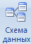 button.
- If there were no links between the database tables, then when you open the Data Schema
window, the Add Table (Добавить таблицу) window opens in which you select the
Employees, Clients, and Orders tables.
- If the relationships between the tables have already been set, then to add a new table to
the data schema, right-click the data schema and select Add Table (Добавить таблицу)
from the shortcut menu.
- Establish links between the Employees and Orders tables by selecting the Employee code
field in the Employees table and drag it to the appropriate field in the Orders table.
- After you drag and drop fields, the “Change Link” dialog box opens (see Figure 1), which
includes the Ensure integrity condition check box. This will prevent cases of deleting records from one table, in which the associated data of other tables remain unconnected.

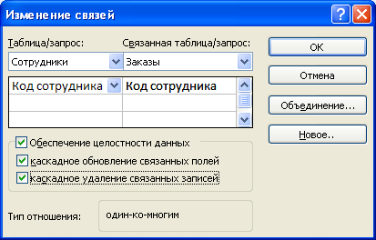
Fig. 1. Creating a links between tables

- Checkboxes “Cascading update of linked fields” and “Cascading deletion of linked
fields” allows simultaneous updating or deletion of data in all subordinate tables when
they are changed in the main table.
- After you have made all the necessary settings, click OK.
- Similarly create links between the tables Clients and Orders.
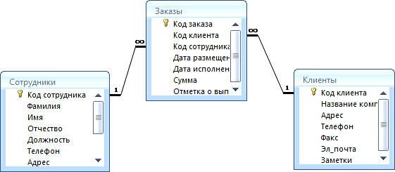
- As a result, the data schema presented in Figure 2 should be obtained:
Fig. 2. Data scheme

In this example, one-to-many relationships are used. In the data schema, they are displayed as trunks with special icons near the tables. A one-to-many relationship is marked "1" near the main table (having a primary key) and "∞" near the subordinate table (which has a foreign key). One-to-one communication is marked with two "1" (both fields of the tables have primary keys). Undefined communication has no signs. If a join is set, its direction is indicated by an arrow at the end of the connecting line (none of the merged fields is key and has no unique index).
- In the table Clients enter information about the seven enterprises with which the firm
operates.
- In the Orders table, fill in info about six orders received by the firm.
- Save your database. File - save as - Access database.

Selecting data using queries

Queries are the primary means of viewing, selecting, modifying, and analyzing information that is contained in one or more tables of the database.

- Open the "Company" database.
- Run the command: Create → Query Wizard → Simple Query (Создание → Мастер
запросов → Простой запрос.).
- In the dialog box that appears (Figure 3), specify the Employee table and select the
Surname, Name, and Phone fields. Click "Next.
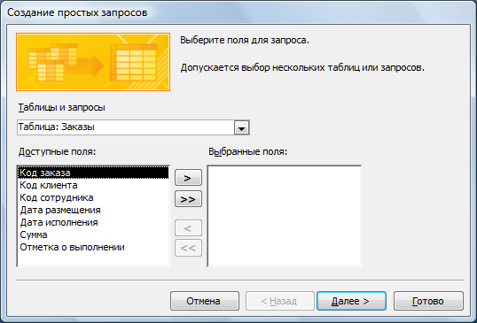
Fig. 3. Creating a simple query

- Type the name of the request - Phones - and click Finish. Thus, we created a query in
which you can see the phones of employees.
- Next query will be created using the Design mode, for this, run the command: on the
ribbon → Create → Query Builder (Создание → Конструктор запросов).
- In the “Add Tables” dialog box, select the Clients table and click the Add button, and
then click Close.
- To transfer the required fields to the request form, double-click on them with the left
mouse button (Figure 4).
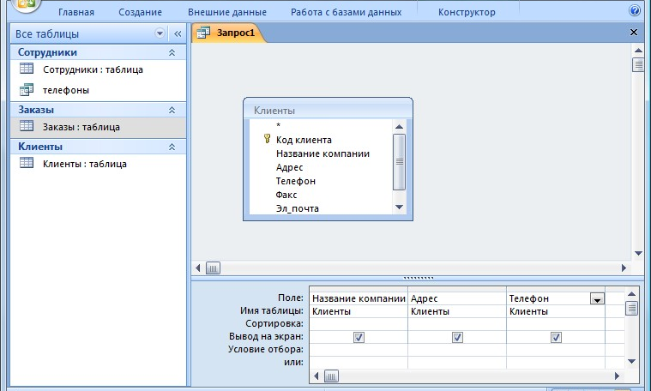
Fig. 4. Create a query in Design mode

- To sort entries in the Company name field in alphabetical order, select the item in
ascending order in the Sort (Сортировка) drop-down list box.
- Save the query with the name "Customer Addresses".
- Create a "Birthdays" query, in which you can view employee birthdays.
- Let's say we want to know which employee has a birthday in the current month, for
example, in April. To do this, open the query in Design mode.
- In the “Selection condition” (Условие отбора) line for the Date of birth field, enter
*.04.* In this entry * means that the date and year of birth can be any, and month 4 (i.e. April). After that, the query window should look like it is shown in Fig. 5.

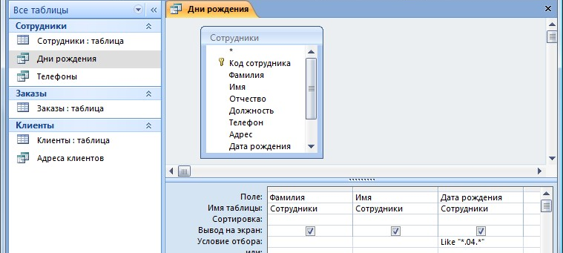
Fig. 5. Creation of a query

- Review the result of a query. To do that press Run button in design mode (Выполнить).
If there are no records in the Birthdays request, then in the Employees table there is not a
single person born in April. Add a few people born in April to the Employees table and
see how the query changes. Requests are automatically updated every time you open them.
If we need to find out which employees were born in May, then we will have to create anew request or change the condition in the existing Birthdays request. This procedure is
inconvenient and takes a lot of time. If you have to frequently execute a query, but each
time you use a new condition value, you use a query with a parameter. When you run this
query, a dialog box appears for entering the value as a selection condition. To create a
query with a parameter, the user must enter the text of the message in the line for
selecting the request form (see Figure 6).
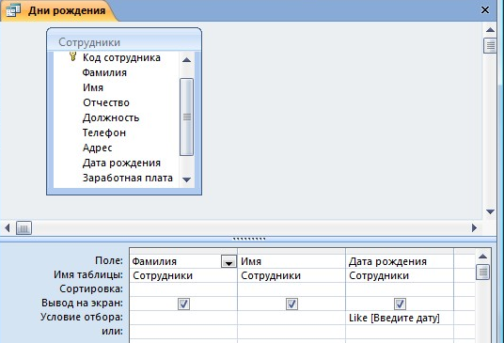
- “Like [Enter Date]” means that when you open the query, a dialog box appears (Figure 7)
with the text "Enter Date" and the field for entering the selection condition. If you enter the condition *.04.*, the list of employees born in April will appear in the query. Run the query again and enter a value *.05.* Check, how the request has changed.

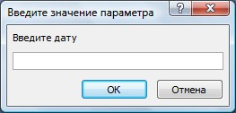
Fig. 7. Window for entering the selection condition

- Change the "Phones" query so that when it starts up, a dialog box with the message
"Enter last name" is displayed. Since you need to derive a specific surname in the query, you do not need to write the word Like in the selection condition.
- Change the request for "Phones" so that when you run it you are asked not only the name,
but also the name of the employee.
- Create a request "Completed Orders" containing the following information: surname and
name of the employee, the name of the company with which he works, a note on the execution and the amount of the order. Take the query data from several tables.
- In the “Selection condition” field for the Completion mark field, enter Yes, so that only
the completed orders are displayed in the query.
- Make sure that the Completion mark column is not displayed.
- Create a request Order amount, in which will be displayed only orders for the amount of
more than $50 000.
- Change the query to make the order amount from $20 000 to $50 000. For query data in
the “Selection condition”, you can use comparison operators >, <, =,> =, <=, <> and logical operators And, Or, Not, etc.
- Sometimes in queries you need to make some calculations, for example, calculate the
income tax of 13% for each transaction. To do this, open the Order amount query in Design view.
- In the blank column of the request form, right-click the Field box (Поле), and click Build
(Построить) on the shortcut menu that appears. You will see the Expression Builder (Построитель выражений) window (Figure 8), which consists of three areas: expression fields, operator buttons and expression elements. Above is the field of the expression in which it is created. The entries entered in this field are selected in the other two areas of the Builder window.
- In the left list, open the Queries folder (Запросы) and select the Order Amount. In the
middle list, highlight the Amount field (Сумма) and click the Insert button (Вставить). The identifier of this field appears in the field of the Builder expression.
- Click the * button and enter 0.13 (see Figure 8). Thus, we will calculate the income tax of
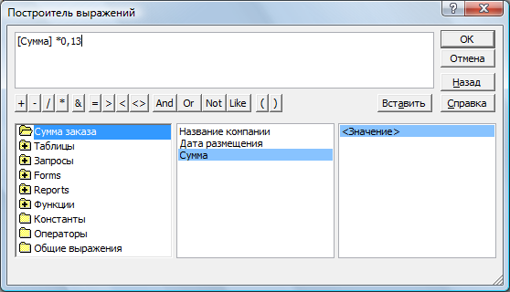
13%.
Fig. 8. The expression builder

- Click the OK button, and then the value "Expression1: [Amount] * 0.13" appears in the
cell of the Field property.
- Replace Expression1 with the Tax and close Design mode.
- Open the query and check the result
- Using the Expression Builder, add the Profit field in the Order amount query, which will
calculate the revenue from the order (that is, the amount minus the tax).
- Create a query Managers, through which in the Employees table find all the managers of
the company.
- Save your database. File - save as - Access database.

Using forms in the database
Forms are database objects designed to view data from tables and queries, to enter data into the database, to correct existing data, and to perform specified actions. The form can contain graphs, drawings and other embedded objects.
You can enter data into tables without the help of any forms. But there are several reasons that make forms an indispensable means of entering data into the database:
- when working with forms, access to tables (the most valuable in the database) is restricted;
- different people may have different access rights to information stored in the database. To enter data, there are different forms, although the data from the forms can come in one table;
- it is easier to enter data into forms than to a table, and it is more convenient, since as a rule, one record of the table is displayed in the form window;
- in most cases, information for databases is taken from paper forms (questionnaires, invoices, certificates, etc.). Screen forms can be made an exact copy of paper forms, thereby reducing the number of errors in the input and reducing the fatigue of personnel.
You can create forms on the basis of several tables or queries using the Wizard using the “autoform” tool, manually in Design mode, saving the table or query as a form. The form created in any way can be changed in Design mode.
- Run the command: Create → Forms → Other forms → Form Wizard (Создание → панель инструментов Формы → Другие формы → Мастер форм).
- In the Create Form (Создание форм) dialog box, select the tables (queries) and the fields that will be placed in form (all fields of Employee table). Click the Next (Далее) button.
- In the next dialogs of the wizard, select the appearance of the form, style, and specify the name of the form. Click the Finish button.
- Using the Wizard, create the Clients, Orders, and Managers (fields of Clients, Orders tables and Managers query) forms.
- Open the Employees form in Design view. This mode is for creating and editing forms.
- Place the items in a convenient order for you, change the size and color of the text (green text, size:13pt).
- In the title of the form, add text “Employees of the Company”.
- In the form footer, add Button object: Design ribbon → Controls toolbar (вкладка ленты Конструктор →панель инструментов Элементы управления).
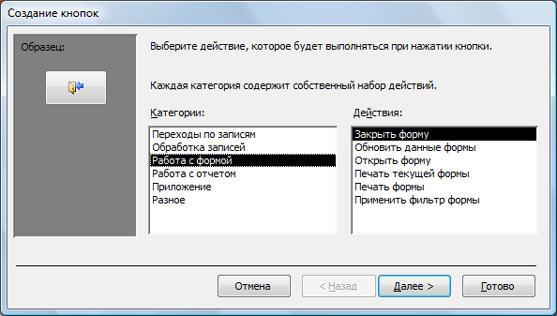
- After you "draw" the button with the mouse pointer, the Create Button dialog box appears (Figure 9).
Fig. 9. Creating buttons on the form

- In the “Work with form” (Работа с формой), select “Close form” (Закрыть форму) action and click Next.
- Select the picture or text that will be placed on the button.
- In the last dialog of the Button Wizard, specify the name of the button (Close button) and click Finish.
- The button wizard wrote a procedure for this button in the Microsoft Visual Basic language. You can view the procedure for processing the event using the Event Handling (Обработка событий) command of the context menu of the button.
- Create the «Close Application», «Record Search», «Delete Entry» buttons by yourself.
- Sometimes on the form you need to place several pages containing data from various sources, reference or auxiliary information. You can use a set of tabs for this purpose.
- Create an empty form.
- To add a tab-set to the form, click the “Tab” (Вкладка) button on the Controls toolbar (Элементы управления). First, only two tabs with the formal names ‘Tab 1’ and ‘Tab 2’ will be added.
- Add one more tab to the tab-set.
- Rename the tabs so that they display the names of the data that will be placed in them: «Employees», «Managers», «Help».
- Click the «Employees» tab and drag the «Employees» form from the navigator panel onto the tab.
- Similarly, place the Managers form. Onto the Help tab, display some tips for working with the database (take them from this file).
- Save this form with the name “Employees of the Company”.
- In Microsoft Access, you can create button forms. They contain only buttons and are designed to select the basic actions in the database. To create a button form, on the tab Work with databases, select the command button manager (Работа с базами данных выбрать команду Диспетчер кнопочных форм).
- If there is no button form in the database, you will be asked to confirm its creation. Click Yes in the confirmation dialog.
- You will see the Button Form Manager in which you click on the New button.
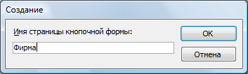
- In the New dialog box (Figure 10), enter the name of the new button form and click OK.
Fig. 10. Specifying the name of the button

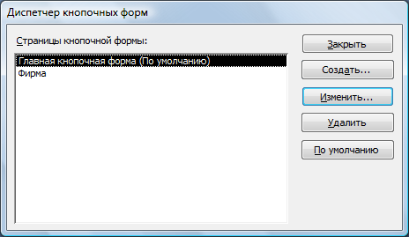
- The name of the new button form will be added to the List of Button-forms (Страницы кнопочной формы) of the Command Button wizard (Диспетчер кнопочных форм) (Figure 11). Highlight the name of the new button form and click the Edit (Изменить) button.
Fig. 11. Command Button wizard

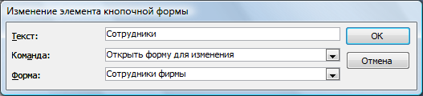
- In the Edit button page of the Command button wizard (Диспетчер кнопочных форм), click “New button”. “Edit button element” (Изменение элемента кнопочной формы) dialog box appears (Figure 12).
Fig. 12. Creating buttons

- In the Text field (Текст), enter header for the first button of the button form, and then select the command from the drop-down list in the Command field (Команда). In the Form field (Форма), select the form for which this command will be executed.
- Similarly, add the «Clients», «Orders», «Exit» buttons.
- In the Command Button wizard (Диспетчер кнопочных форм) dialog box, select the name of your button form and click the Default (По умолчанию) button.
- The name ("default)" appears next to the name of the button form.
- To complete creation of the button form, click the Close button.
- 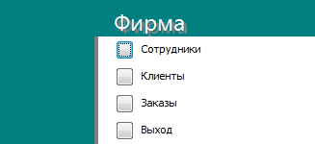As a result, the form shown in Fig. 13 will be displayed.
Fig. 13. Main button form

- Add some image to the form.
- In order for the main button form to appear on the screen when the application Access is launched, it is necessary to click on the Access Parameters button in the main menu. For the current database, set the "button form view”.
- Save your database. File - save as - Access database.

